

NexForge AI :Autonomous AI-Powered Repository Intelligence Platform

PROJECT REPORT

Submitted by
RITHIK CA (714023243116)
SHAKTHIVEL PARIMALAM KPC (714023243134)
SRINIVASAN N (714023243149)
VENKATRAMAN R (714023243160)

In partial fulfillment for the award of the degree of
BACHELOR OF TECHNOLOGY
IN
ARTIFICIAL INTELLIGENCE AND DATA SCIENCE

SRI SHAKTHI
INSTITUTE OF ENGINEERING AND TECHNOLOGY
COIMBATORE 62

An Autonomous Institute, Accredited by NAAC with “A” Grade
ANNA UNIVERSITY: CHENNAI 600 025
NOV - 2026
BONAFIDE CERTIFICATE

Certified that this report titled “NexForge AI :Autonomous AI-Powered Repository Intelligence Platform” is the bonafide work of “RITHIK CA (714023243116), SHAKTHIVEL PARIMALAM KPC (714023243134), SRINIVASAN N (714023243149), VENKATRAMAN R (714023243160)” who have carried out this project work under our supervision.

SIGNATURE | SIGNATURE
Dr. Saravana Kumar N M | Dr. Saravana Kumar N M
HEAD OF THE DEPARTMENT | PROJECT GUIDE
Department of Artificial Intelligence and Data Science | Department of Artificial Intelligence and Data Science
Sri Shakthi Institute of Engineering and Technology  Coimbatore - 641062 | Sri Shakthi Institute of Engineering and Technology  Coimbatore - 641062

Submitted for the project work viva voce examination held on ………………………..

Internal Examiner External Examiner
ACKNOWLEDGEMENT

We express our deepest gratitude to our Chairman Dr.S.Thangavelu for his continuous encouragement and support throughout our course of study.

We are thankful to our Secretary Dr.T.Dheepan for his unwavering support during the entire course of this project work.

We are also thankful to our Joint Secretary Mr.T.Sheelan for his support during the entire course of this project work.

We are highly indebted to Principal Dr.N.M.Saravana Kumar for his support during the tenure of the project.

I would like to acknowledge and express deep gratitude to the Head of the Department of Artificial Intelligence and Data Science, Dr.N.M.Saravana Kumar, (HOD/AIDS) for providing us with essential facilities and a conducive environment for our project work.

It’s a great pleasure to thank our Project Guide Ms.SINI PRABHAKAR (AP/AIDS) for her valuable technical suggestions and continuous guidance throughout this project work. I am also thankful to our Project Coordinators, Ms.SINI PRABHAKAR (AP/AIDS) for their support, encouragement, and for providing us with the necessary facilities to carry out our project effectively.

We solemnly extend our thanks to all the teachers and non-teaching staff of our department, family and friends for their valuable support.

RITHIK CA
SHAKTHIVEL PARIMALAM KPC
SRINIVASAN N
VENKATRAMAN R

ABSTRACT
Modern software projects receive a continuous stream of bug reports and feature requests through issue-tracking platforms such as GitHub Issues. Resolving these issues traditionally requires a developer to read the issue, understand an often unfamiliar codebase, locate the affected components, design and implement a fix, run the project's tests, and finally open a pull request. This process is manual, time-consuming, and difficult to scale as the number of open issues grows.
This project proposes NexForge AI, an autonomous system that converts GitHub issues into validated, tested pull requests with minimal human intervention. The system is built using FastAPI, Tree-sitter, Neo4j, LangChain, LangGraph, OpenAI GPT, Docker, and the GitHub API. When an issue is opened and labeled for automated repair, NexForge AI receives a GitHub webhook, clones the target repository into an isolated workspace, parses the source code using Tree-sitter, and stores the relationships between files, functions, classes, imports, and calls as a code knowledge graph in Neo4j.
A graph-based retrieval layer (Graph RAG) then identifies the code most relevant to the reported issue by traversing this graph, rather than relying on similarity search alone. A multi-agent workflow, orchestrated with LangGraph, uses this context to diagnose the root cause, generate a candidate patch, and validate it by executing the project's test suite inside a sandboxed Docker container that has no network access and runs as a non-root user. A pull request is opened automatically only when the tests pass; if the patch fails, the system retries within a configured limit and, failing that, escalates the issue for human review while preserving the diagnosis and the failed patch for reference.
The current version of NexForge AI targets Python and JavaScript/TypeScript repositories. By combining static code-graph understanding, retrieval-augmented generation, autonomous multi-agent reasoning, and isolated test validation, the system aims to reduce the manual effort involved in routine software maintenance while keeping a human reviewer in the loop for cases where automation is uncertain.

TABLE OF CONTENTS
CHAPTER NO TITLE PAGE NO.
ABSTRACT 4
1. INTRODUCTION 8
1.1 Background 8
1.2 Problem Statement 8
1.3 Motivation 9
1.4 Objectives 9
1.5 Scope 10
1.6 Limitations 10
2. LITERATURE REVIEW 11
3. EXISTING SYSTEM 12
3.1 Manual Issue Analysis 12
3.2 Dependence on Technical Users 12
3.3 Traditional Static Analysis 12
3.4 Vector-Only Code Search 13
3.5 Rule-Based Automated Repair 13
3.6 Limited Test Validation 13
3.7 Lack of Autonomous Processing 13
4. PROPOSED SYSTEM 14
4.1 Natural Language Issue Input 14
4.2 Repository Cloning 14
4.3 Source Code Parsing 15
4.4 Code Knowledge Graph 15
4.5 Incremental Indexing 15
4.6 Graph RAG Retrieval 16
4.7 Multi-Agent Workflow 16
4.8 Docker Sandbox 16
4.9 Pull Request Generation 17
5. SYSTEM DESIGN AND ARCHITECTURE 18
6. SOFTWARE AND TECHNOLOGY DESCRIPTION 20
7. IMPLEMENTATION AND SOURCE CODE 23
8. RESULTS AND ANALYSIS 27
9. CONCLUSION AND FUTURE SCOPE 31
REFERENCES 33

CHAPTER 1

INTRODUCTION

1.1 Background
Modern software projects receive bugs and feature requests through issue-tracking systems such as GitHub Issues. Developers must inspect the issue, understand the codebase, locate the affected functions, reproduce the problem, implement a solution, test the change, and submit a pull request.
This workflow becomes difficult when the repository is large, the issue description is incomplete, the codebase is unfamiliar to the developer, the error spans multiple files, existing tests are difficult to understand, or developers must handle many issues simultaneously. NexForge AI applies artificial intelligence and code-graph analysis to automate this maintenance workflow end to end.

1.2 Problem Statement
Existing development workflows do not provide a complete autonomous process for converting an issue report into a safe, tested, reviewable code change. The problem addressed by this project is stated as follows:
How can an AI system understand a software repository, diagnose a GitHub issue, generate a valid patch, test the patch securely, and create a pull request without executing untrusted code directly on the host system?

1.3 Motivation
The main motivations behind this project are:
- Reduce time spent on repetitive debugging.
- Help developers maintain unfamiliar repositories.
- Automatically reproduce and validate common bugs.
- Improve overall issue resolution speed.
- Provide traceable, explainable AI-generated changes.
- Ensure generated code is tested before it reaches a human reviewer.
- Keep human developers involved when automation is uncertain.

1.4 Objectives
The objectives of this project are to:
- Receive GitHub issue events through a webhook, Clone the target repository into an isolated workspace.
- Parse Python and JavaScript/TypeScript source code., Build a graph of code entities and their relationships.
- Retrieve relevant code context using graph relationships, Identify the probable root cause of a reported issue.
- Generate a unified code patch., Execute the project's tests inside a Docker sandbox.
- Retry failed patches safely within a configured limit, Flag unresolved issues for human review.
- Create a GitHub branch and pull request after successful validation.

1.5 Scope

In Scope
- Single repository per analysis run, Python repositories.
- JavaScript and TypeScript repositories, GitHub Issues and GitHub Pull Requests.
- Tree-sitter based parsing, Neo4j code knowledge graph.
- OpenAI GPT integration, Docker-based isolated test execution.
- SQLite job tracking, Human-review fallback for uncertain cases.

Out of Scope
- Multi-repository dependency analysis, GitLab and Bitbucket support.
- Support for every programming language, Automatic production deployment.
- Fully autonomous merging without human approval, Organization-wide analytics.
- Guaranteed correctness of AI-generated patches.

1.6 Limitations
- LLM output can be incorrect and requires validation before use.
- Some issues lack enough information for an automated diagnosis.
- Test suites may be incomplete or flaky, affecting validation reliability.
- A working Docker installation is required for real sandbox execution.
- Neo4j requires an active, reachable database instance.
- GitHub pull request creation requires authentication and repository permissions.
- Complex cross-repository bugs are outside the scope of the first version.

CHAPTER 2

LITERATURE REVIEW
Automated software repair and AI-assisted development have been active areas of research. This chapter reviews the key areas of prior work that inform the design of NexForge AI.

2.1 Automated Program Repair
Automated program repair (APR) systems generate patches for known defects. Many traditional APR systems depend on predefined mutation rules, genetic search over candidate patches, or example-based transformations derived from historical bug fixes. These approaches can be effective for narrow classes of bugs but generalize poorly to the wide variety of issues seen in real-world repositories.

2.2 Large Language Models for Code
Large Language Models (LLMs) trained on large code corpora can understand source code, explain errors, generate new code, and suggest fixes in natural language and code simultaneously. However, LLM output is not guaranteed to be correct, so any LLM-generated patch requires independent validation, typically through automated testing, before it can be trusted.

2.3 Retrieval-Augmented Generation
Retrieval-Augmented Generation (RAG) supplies an LLM with relevant external context before it generates a response, improving factual grounding. Basic RAG implementations typically rely on vector similarity search over embedded text chunks. NexForge AI extends this idea by retrieving related files and symbols through an explicit code graph rather than embeddings alone, which captures exact structural relationships that similarity search can miss.

2.5 Agent-Based Software Engineering
Agent-based systems divide the software engineering process into cooperating roles, such as debugging, coding, testing, and review, with each role handled by a specialized agent. Coordinating these agents through an explicit state machine or graph allows for retries, escalation, and clearer traceability compared to a single monolithic prompt.

2.7 Research Gap
Many existing tools address only one part of the issue-resolution process: some generate suggestions without validating them, some validate patches without understanding the broader repository structure, and others stop short of producing a reviewable artifact.

CHAPTER 3

EXISTING SYSTEM

3.1 Manual Issue Analysis
In the traditional workflow, a developer reads the issue report and manually searches the repository to locate the affected code, relying on personal familiarity with the codebase.

3.2 Dependence on Technical Users
Only developers who are already familiar with the codebase can quickly identify the affected components, which creates a bottleneck when experienced maintainers are unavailable.

3.3 Traditional Static Analysis
Static analysis tools can detect syntax errors, type errors, or known unsafe patterns, but they generally do not understand natural-language issue descriptions or connect them to the underlying root cause.

3.4 Vector-Only Code Search
Vector-based semantic search can find files that are textually or conceptually similar to a query, but it may miss exact structural relationships such as callers, callees, imports, and class inheritance that are essential for a correct diagnosis.

3.5 Rule-Based Automated Repair
Rule-based repair systems work well for known, previously catalogued bug patterns, but they are difficult to generalize to novel issues that do not match an existing rule.

3.6 Limited Test Validation
Some existing tools generate a candidate patch without executing the full project test suite, which means an incorrect patch can be proposed with no automated evidence of correctness.

3.7 Lack of Autonomous Processing
Existing tools frequently stop at producing a suggestion or a diff for a human to apply manually, rather than producing a tested, ready-to-review pull request.

CHAPTER 4

PROPOSED SYSTEM

4.1 Natural Language Issue Input
The system receives the issue title, issue body, any stack trace included in the report, repository information, the issue number, and its labels. Only issues labeled ai-fix, or otherwise configured for automation, are processed by NexForge AI.

4.2 Repository Cloning
The repository cloner performs the following sequence of steps for each analysis run:
- Creates a temporary, isolated workspace.
- Detects the repository's default branch.
- Performs a shallow clone of the repository.
- Creates a dedicated working branch, for example ai-fix/issue-42.
- Cleans up the workspace once the run completes.

4.3 Source Code Parsing
The Tree-sitter based parser extracts files, functions, classes, methods, imports, function calls, inheritance relationships, signatures, documentation strings, start and end line numbers, and SHA-256 content hashes for every source file it processes.

4.4 Code Knowledge Graph
Neo4j stores the parsed entities as graph nodes, including File, Function, Class, and Import nodes, connected by relationships such as DEFINES, HAS_METHOD, CALLS, IMPORTS, and EXTENDS. This graph represents the structural relationships within the repository that a diagnosis depends on.

4.5 Incremental Indexing
Before writing a file's data to Neo4j, the system compares the file's current content hash with the previously stored hash. If the hash is unchanged, the file is skipped; if it has changed, the file is re-parsed and both its graph nodes and relationships are updated. This reduces processing time substantially on large repositories where only a small fraction of files change between runs.

4.6 Graph RAG Retrieval
The retriever extracts candidate file names and symbols mentioned in the issue, searches Neo4j for matching nodes, traverses connected nodes within a configured number of hops, formats the resulting graph context for the language model, and limits the total amount of context passed to the model to keep prompts within budget.

4.7 Multi-Agent Workflow
The LangGraph workflow coordinates three specialized agents. The Debugger Agent analyzes the retrieved context to identify the likely root cause and affected files. The Coder Agent generates a unified diff implementing the fix. The Tester Agent executes the project's test suite inside the Docker sandbox. If the tests pass, the PR Generator step creates the pull request. If the tests fail and retries remain, control returns to the Coder Agent; once the maximum retry count is reached, the job is routed to human review instead of being silently discarded.

4.8 Docker Sandbox
The sandbox uses language-specific container images, mounts only the temporary workspace directory, disables network access, runs as a non-root user, enforces memory and CPU limits, applies an execution timeout, and captures the process's standard output, standard error, and exit code for later inspection.

4.9 Pull Request Generation
A pull request generated by NexForge AI contains a title in the form Fix: {issue title}, a summary of the diagnosed root cause, the list of changed files, the captured test output, a Closes #{issue_number} reference, an ai-generated label, and the correct source and target branches.

CHAPTER 5

SYSTEM DESIGN AND ARCHITECTURE

5.1 High-Level Architecture
NexForge AI is organized as a set of cooperating services: a FastAPI ingress layer that accepts GitHub webhooks, a SQLite-backed job queue that decouples request handling from long-running analysis work, a pool of queue workers that perform the actual repository analysis, and the graph, agent, and sandbox subsystems described in Chapter 4.
GitHub Issue --> FastAPI Webhook --> SQLite Job Queue --> Queue Worker
--> Repository Clone --> Tree-sitter Parser --> Neo4j Code Graph
--> Graph RAG Retrieval --> Debugger Agent --> Coder Agent
--> Docker Test Sandbox --(fail)--> Retry / Human Review
--(pass)--> Git Commit and Push --> GitHub Pull Request

5.2 Data Flow
A GitHub webhook event is first validated using an HMAC signature check, then converted into a job record in the SQLite queue. A queue worker claims the job, clones the repository, and streams parsed entities into Neo4j. The retriever then queries Neo4j to build a context bundle, which is passed to the agent workflow. The Coder Agent's output is applied to the cloned workspace, and the Tester Agent's Docker execution results determine whether the workflow proceeds to pull request creation, a retry, or human review.

5.3 Component Design
The system is composed of the following major components: FastAPI Ingress, SQLite Job Queue, Queue Worker, Repository Cloner, Tree-sitter Parser, Neo4j Graph Builder, Graph RAG Retriever, Debugger Agent, Coder Agent, Tester Agent, and PR Generator.

5.4 Database Design
Two data stores are used. SQLite stores job metadata, including job ID, job status, retry count, the original payload, any error message, the result, and the scheduled retry time. Neo4j stores the code knowledge graph itself, using idempotent MERGE queries so repeated indexing runs do not create duplicate nodes or relationships.

5.5 Security Design
Incoming webhooks are verified using an HMAC signature computed with a shared secret, rejecting any request that does not match. All code generated by the agents is executed only inside the Docker sandbox.

CHAPTER 6

SOFTWARE AND TECHNOLOGY DESCRIPTION

6.1 Python
Python is used throughout the backend for orchestration, parsing, agent logic, GitHub integration, test execution control, and database access, owing to its strong ecosystem for AI and web-service development.

6.2 FastAPI
FastAPI exposes the system's HTTP interface, including endpoints such as:
GET /health
POST /webhook/github
POST /repos/analyze
POST /jobs/run-next
GET /jobs/{job_id}

6.3 Tree-sitter
Tree-sitter provides fast, incremental, language-aware parsing for Python, JavaScript, TypeScript, and TSX source files, producing the abstract syntax trees that the graph builder consumes.

6.6 OpenAI GPT
GPT models are used for issue analysis, root-cause identification, patch generation, and test-log summarization. If no API key is configured, a deterministic fallback path is used so that the rest of the pipeline can still be exercised during local testing.

6.7 Docker
Docker provides the isolated execution environment in which generated patches are applied and the project's tests are run, keeping untrusted, AI-generated code away from the host system.

6.8 GitHub API
The GitHub API, accessed through PyGithub, is used for repository access, pull request creation, label assignment, and branch management support.

6.9 SQLite
SQLite stores job metadata for local development, mock execution, and lightweight deployments where a separate queue service is not required.

CHAPTER 7

IMPLEMENTATION AND SOURCE CODE

7.1 Project Structure
The project is organized into clearly separated modules, one per subsystem, which keeps the cloning, parsing, graph, retrieval, agent, sandbox, GitHub integration, and job-queue logic independently testable:
NexForgeAI/
├── app/
│ ├── main.py
│ ├── worker_main.py
│ ├── config.py
│ ├── cloning/
│ │ └── repo_cloner.py
│ ├── parsing/
│ │ └── treesitter_parser.py
│ ├── graph/
│ │ ├── neo4j_client.py
│ │ └── graph_builder.py
│ ├── retrieval/
│ │ └── graph_rag.py
│ ├── agents/
│ │ ├── state.py
│ │ ├── debugger_agent.py
│ │ ├── coder_agent.py
│ │ ├── tester_agent.py
│ │ └── orchestrator.py
│ ├── sandbox/
│ │ └── docker_runner.py
│ ├── github_integration/
│ │ ├── webhook_verify.py
│ │ └── pr_generator.py
│ └── jobs/
│ ├── queue.py
│ └── worker.py
├── tests/
├── requirements.txt
├── .env.example
├── .gitignore
└── README.md

7.2 Webhook Implementation
The webhook endpoint verifies the X-Hub-Signature-256 header against an HMAC-SHA256 digest of the request body, computed using the shared GITHUB_WEBHOOK_SECRET, before accepting the payload. Requests with an invalid or missing signature are rejected with an authentication error.

7.3 Repository Cloner
The repository cloner module wraps Git command-line operations to perform a shallow clone into a temporary directory, create the working branch for the fix, and remove the workspace once the job finishes or fails.

7.4 Tree-sitter Parser
The parser module loads the appropriate Tree-sitter grammar for each file's language and walks the resulting syntax tree to extract the entities described in Section 4.3, attaching a SHA-256 hash of each file's content for incremental indexing.

7.5 Graph Builder
The graph builder module translates parsed entities into Neo4j MERGE statements, ensuring that re-running the indexer on an unchanged repository does not create duplicate nodes or relationships.

7.6 Graph RAG Retriever
The retriever module extracts candidate symbols from the issue text, queries Neo4j for matching or related nodes, expands the result set by a configured number of hops, and serializes the resulting subgraph into a compact textual context block for the LLM.

7.7 Agent Workflow
The agent workflow module defines the LangGraph state machine described in Section 4.7, including the shared state object passed between the Debugger, Coder, and Tester agents, and the conditional edges that implement the retry and human-review logic.

7.8 Docker Sandbox
The Docker sandbox module builds the container invocation with the isolation settings described in Section 4.7 - Section 5.5, mounts the workspace read-write, executes the project's test command, and returns structured output including exit code and captured logs.

7.9 PR Generator
The PR generator module commits the applied patch, pushes the working branch to the repository, and calls the GitHub API to open a pull request with the title, body, and labels described in Section 4.9.

7.10 Queue Worker
The queue worker module polls the SQLite job queue, claims the next available job, and drives it through the cloning, parsing, retrieval, agent, sandbox, and pull-request stages, updating the job's status and retry count as it progresses.

CHAPTER 8

RESULTS AND ANALYSIS

8.1 Webhook Validation Test
The webhook endpoint was tested against the following cases: a valid HMAC signature, an invalid signature, a missing secret, an unsupported GitHub event type, an issue without the ai-fix label, and an issue with the ai-fix label. Only the last case, an appropriately labeled issue with a valid signature, resulted in a job being queued for processing.

8.2 Queue Testing
The job queue was tested for job creation, job claiming, job completion, job failure, retry scheduling, behavior at the maximum retry count, and transition to human-review status. Each transition updated the job record consistently with the expected state.

8.4 Incremental Indexing
The graph builder was tested by indexing a repository twice without modification. On the second run, files with unchanged content hashes were skipped, while a deliberately modified file was re-parsed and its graph entry updated. A representative test output is shown below.
Files processed: 1
Files skipped: 1

8.5 Patch Generation Test
The Coder Agent was tested to confirm that generated diffs are limited to the files identified as relevant by the Debugger Agent, and do not introduce unrelated changes elsewhere in the repository.

8.7 Human Review Scenario
When a patch fails validation after exhausting the configured retry limit, the system does not open a pull request. Instead, it stores the failure logs, marks the job as human_review, and preserves the generated patch together with the diagnosis for a human maintainer to inspect.

8.8 Mock End-to-End Test
An end-to-end mock test was run against a seeded repository containing the following intentionally buggy function:
def parse_value(value):
return int(value)
The associated mock issue reported that passing None to this function causes a failure. The system cloned the repository, parsed parser.py, identified the affected file through graph retrieval, generated a None guard, applied the patch, ran the mocked test suite, built the pull request body, and simulated the commit and pull request creation. A representative result is shown below.
STATUS: completed
PATCH APPLIED: True
TEST PASSED: True
PR RESULT: https://example.com/pr/1
Note: this mock end-to-end scenario uses a simulated repository and a mocked GitHub API response rather than a live repository, so the figures above should be reproduced and update.

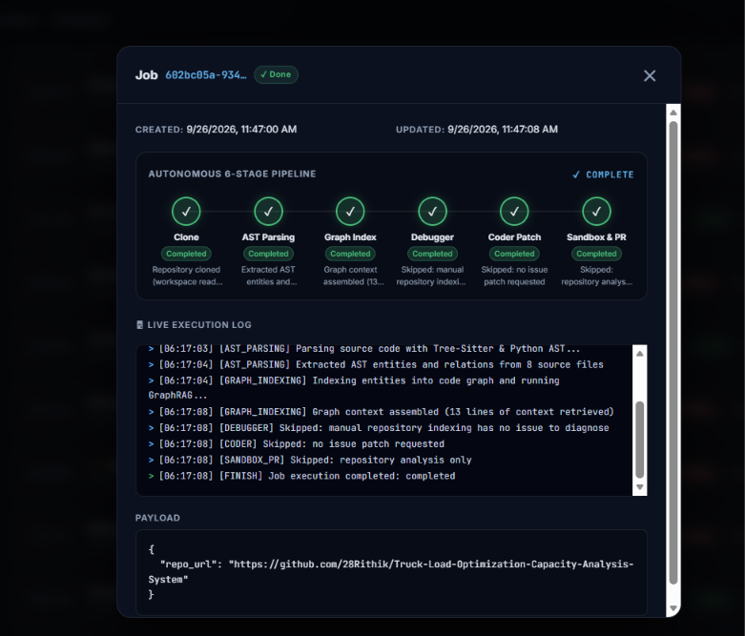

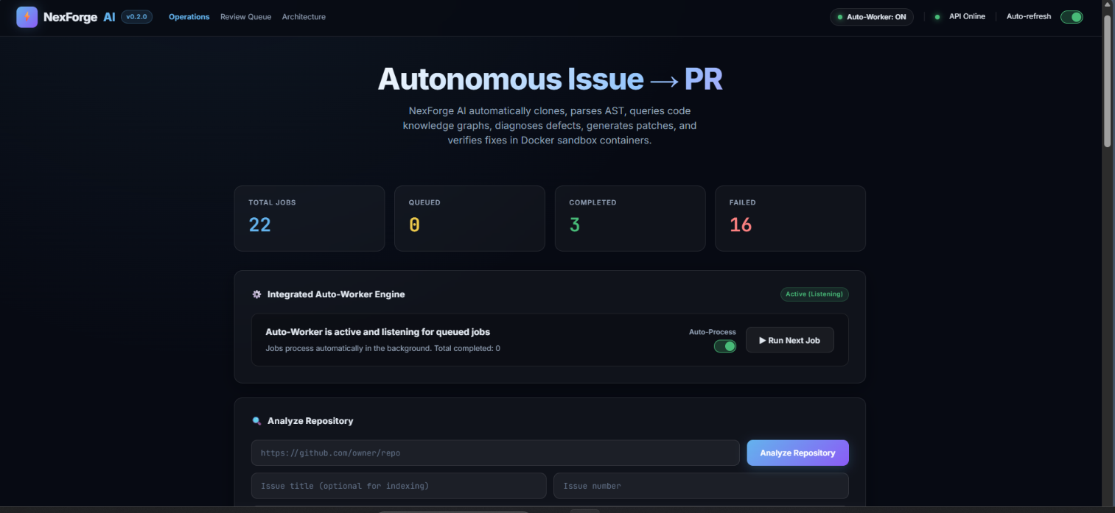

CHAPTER 9

CONCLUSION AND FUTURE SCOPE

9.1 Conclusion
NexForge AI demonstrates an autonomous issue-to-pull-request workflow that combines repository analysis, graph-based code retrieval, LLM-driven reasoning, patch generation, isolated test execution, and GitHub integration into a single pipeline. By validating every generated patch inside a sandboxed test environment before it is proposed as a pull request system reduces the risk of introducing untested changes while still keeping a human reviewer in the loop for uncertain or failed cases.

9.2 Future Scope

9.2.1 Support for More Programming Languages
Future versions could extend Tree-sitter based parsing and the agent workflow to additional languages such as Java, C++, Go, Rust, C#, and Ruby.

9.2.2 Multi-Repository Analysis
The system could be extended to analyze shared libraries and dependencies that span multiple repositories, which would allow it to diagnose issues that originate outside the primary repository.

9.2.3 Improved AI Patch Generation
Improvements could include generating multiple candidate patches, ranking them by estimated quality, applying lightweight formal verification, adopting a test-driven patch-generation strategy, and supporting automatic rollback of a merged patch if it is later found to be faulty.

9.2.4 Enterprise Security
Production deployments could adopt GitHub Apps instead of personal access tokens, integrate with a secrets vault, support private or self-hosted model deployment, add audit logging, enforce role-based access control, and apply repository allowlists and network policy enforcement.

9.2.5 CI/CD Integration
NexForge AI could integrate with CI/CD platforms such as GitHub Actions, Jenkins, GitLab CI, Azure DevOps, and CircleCI, allowing generated patches to be validated against a project's existing continuous-integration pipeline rather than a standalone sandbox alone.

REFERENCES

1. R. Just, D. Jalali, and M. D. Ernst, “Defects4J: A Database of Existing Faults to Enable Controlled Testing Studies for Java Programs,” Proceedings of the International Symposium on Software Testing and Analysis (ISSTA), 2014, pp. 437–440.
2. C. Le Goues, M. Pradel, and A. Roychoudhury, “Automated Program Repair,” Communications of the ACM, vol. 62, no. 12, 2019, pp. 56–65.
3. C. S. Xia, Y. Wei, and L. Zhang, “Automated Program Repair in the Era of Large Pre-trained Language Models,” Proceedings of the 45th International Conference on Software Engineering (ICSE), 2023.
4. P. Lewis, E. Perez, A. Piktus, et al., “Retrieval-Augmented Generation for Knowledge-Intensive NLP Tasks,” Advances in Neural Information Processing Systems (NeurIPS), 2020.
5. F. Yamaguchi, N. Golde, D. Arp, and K. Rieck, “Modeling and Discovering Vulnerabilities with Code Property Graphs,” IEEE Symposium on Security and Privacy, 2014, pp. 590–604.
6. C. Qian, W. Liu, H. Liu, et al., “ChatDev: Communicative Agents for Software Development,” Proceedings of the 62nd Annual Meeting of the Association for Computational Linguistics (ACL), 2024.
7. Tree-sitter Documentation, “Tree-sitter: An Incremental Parsing System,” tree-sitter.github.io.
8. Neo4j Documentation, “Neo4j Graph Database Documentation,” neo4j.com/docs.
9. LangChain Documentation, “LangChain and LangGraph Framework Documentation,” python.langchain.com.
10. FastAPI Documentation, “FastAPI Framework Documentation,” fastapi.tiangolo.com.
11. Docker Documentation, “Docker Engine Security,” docs.docker.com.
12. GitHub REST API Documentation, “Webhooks and Pull Requests,” docs.github.com.
Note: Please verify each citation's details (authors, venue, year, page numbers) and update this list to match the sources you actually consulted before submitting this report.

